**Integrating Machine Learning and Deep Learning Techniques for Emotion Recognition Using NLP**

Team Members:

Manoja Popuri -11708615

Mohammed Firoze Shaik - 11702394

Satish Nallamadugu - 11702466

Jayabhi Sankar Reddy Illuri - 11712966

**Abstract:**

Sentiment analysis is an rising improvement subject matter that plays an important function in psychiatry, patron behaviour management, and digital help conversation This project follows a unique integrated approach where the output from machine learning (ML) models is provided as input to deep learning (DL) models for further refinement. The messages are: basically , there are feelings; Anger, fear, pleasure, love, sadness and surprise. Some facts pre-processing steps like Tokenization, removal of prevent phrases and lemmatization are accomplished on this section. Sensory classifiers are protected inside the present paintings consisting of guide vector machines (SVM), random forests, naive Bayes, logistic regression, long-time period memory (LSTM), convolutional neural networks (CNN), bidirectional LSTM (BiLSTM); and transformer-based totally fashions (e.G., BERT,). Based on a number of metrics which includes accuracy and F1 scores, the results of this model are evaluated and those consequences are plotted and represented in step with the sequence of emotion reputation approaches. This work is useful in developing sentiment popularity systems that may be used for sensible packages.

**1. Motivation:**

Sentiment analysis from textual content is crucial for improving the interaction among people and machines in human conduct research. The availability of social platforms such as Twitter affords wealthy content that represents emotional states. From this records, models can be developed which could understand specific emotions together with – unhappiness, happiness, anger and fear ; It can be very useful in customer service, social media management and even figuring out patients with mental health troubles.

Unlike other works, this work consists of using ML and DL where the counting consequences are fed into the DL version for in addition processing This project objectives to increase those normal ML and DL methods said collectively to extract emotion from text. These efforts hold a promising destiny as the career seeks to shut the space between emotion and how human feels and the way gadget is aware even though the ones are translated into realistic outcomes.

2. Objectives:

The fundamental targets of this application are:

1. Data Collection and Processing: Import Twitter message information set and first procedure the records set, the records set contains six emotions that are, anger, worry, happiness, love, sadness, and shock.

2. Model Development: Trained with machine learning methods (SVM, random forest) and deep learning (LSTM & transformer based models) to identify associated sensitivities.

3. NLP methods: Where it is possible to use techniques such as TF-IDF ranks, word input, transformer models to improve the classification of a given emotion.

4. Evaluation: Check samples of accuracy, exact recall F1 scores to fine-tune models for performance.

5. Visualization: The results can be visualized with the help of confusion matrices and charts for sensory classification to prove the efficiency of the models.

The main objective is to develop a robust emotion recognition model that will be useful in identifying emotions in text corpus and useful for further research.

**Workflow**

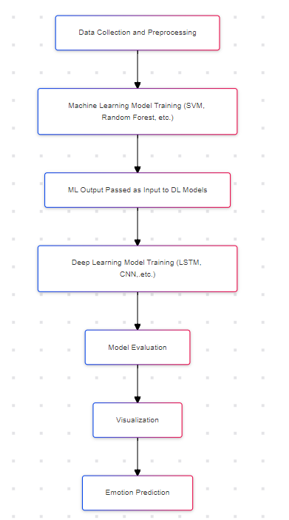

**3. Significance:**

In today’s virtual global, emotion popularity is essential because emotions shape human verbal exchange and choice-making approaches. The increasing reliance on social media systems along with Twitter has led to an boom in captions, often rich in emotional content. By developing a version which can accurately understand feelings from textual content, this project helps in several regions:

• Mental health monitoring: Sentiment analysis of social media posts gives valuable insights into customers’ intellectual health fame. Early identification of terrible feelings consisting of disappointment, anger and worry can make contributions to intervention in cases of emotional misery, necessitating the development of powerful equipment for identifying such feelings

• Customer Sentiment Survey: Companies have an increasing number of relied on automated tools to degree patron pride. Emotion reputation structures assist agencies customize their offerings, improve consumer experience and solve user worries more efficaciously. In such a competitive surroundings, a reliable sentiment reputation gadget is vital for purchaser satisfaction.

• Human-Machine Interaction: As era advances, the want for machines to apprehend human feelings increases From AI-powered chatbots to automated assistants, the mixing of emotion popularity allow extra empathetic and human-like communication.

**4. Features, Deliverables, Uniqueness, and Milestone:**

**Features:**

• Pre-processed sentiment information gathered from Twitter.

• Implementation of go and multi-area fashionable learning fashions and synchronous clever models for sentiment prediction.

• Using sophisticated herbal language processing strategies which includes TF-IDF scoring and lexicalization, or the usage of advanced differences for better outcomes in sensory class.

**Deliverables:**

A deep learning model which is capable to recognizing the emotion and summarize the text.

Text summarization model: Summarization of tweets with performance evaluation.

Activity Reports and Documentation: Detailed reviews together with code, visualizations, and findings.

**Uniqueness:**

• The ML model output is giving to the deep learning model and predict the output using the nlp techniques which increase accuracy of the model.

• An in-depth look at of all strategies and techniques used to perceive emotions in NLP.

• In specific, it will be useful for real-time packages in social media content analysis and mental health.

**Milestones:**

Milestone 1: Data collection and preprocessing (Week 1).

Milestone 2: Model development using ML and DL techniques (Week 2).

Milestone 3: Model evaluation and visualization (Week 3).

Milestone 4: Final report and presentation (Week 4).